**Challenge 1**

/* From the customers table, Select column FirstName, LastName, Address, State */

SELECT FirstName, LastName, Address, State

FROM customers

/*where the FirstName column must be displayed in an alphabetical order and the State column does not contain Null.*/

WHERE State is not null

ORDER BY FirstName ASC

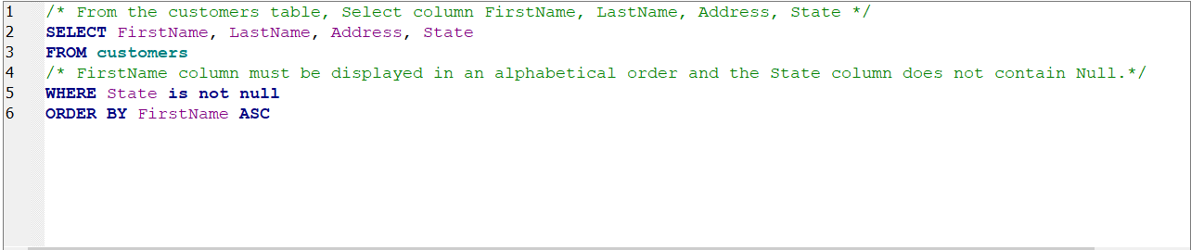

RESULT :

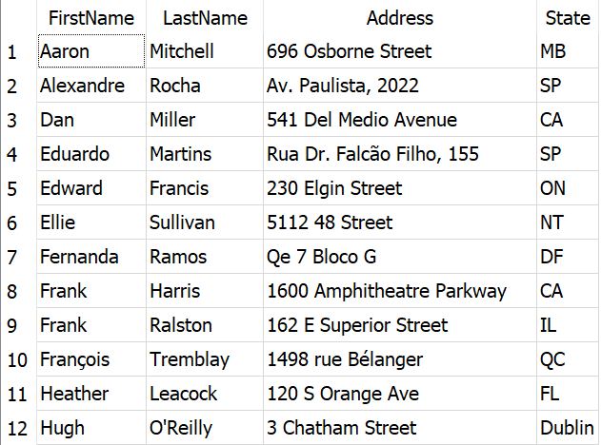 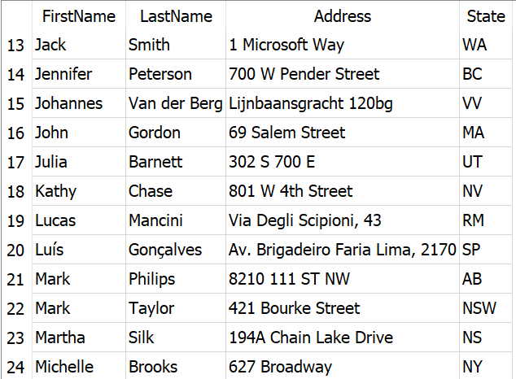

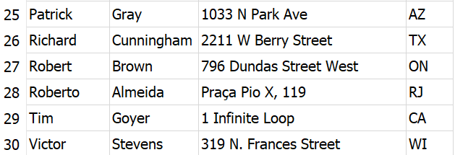

**Challenge 2**

/* From the customers table, Take the CustomerId, phone and email from 5 customers who are in the country USA */

SELECT CustomerId, phone, Email

FROM customers

WHERE Country='USA'

LIMIT 5

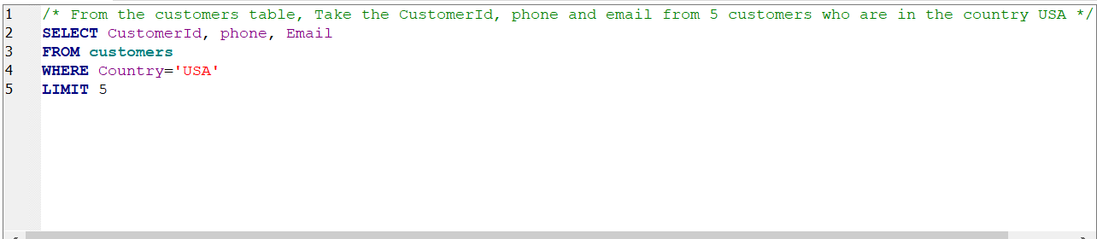

RESULT :

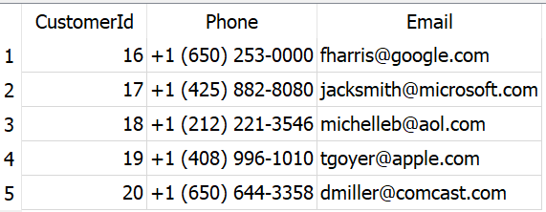

**Challenge 3**

/* From invoices table, retrieve information CustomerId, InvoiceDate, Total transactions > 10,

and sort the Total values from the largest.*/

SELECT CustomerId, InvoiceDate, Total

FROM invoices

WHERE Total > 10

ORDER BY Total DESC

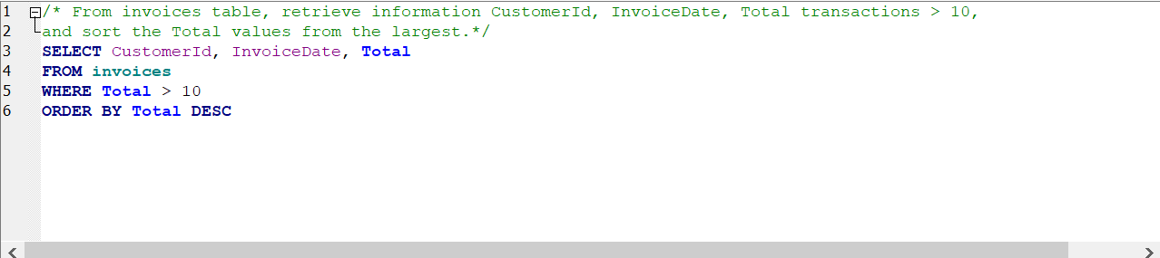

RESULT :

